Turnitin Assignment Creation in LMS Course

This user manual includes following sections:

- Creating Turnitin Assignment (page1)
- Viewing the Turnitin Submission Inbox (page 7)
- Submit Paper on Behalf of a Student (page 9)
- Exclude Sources from the Similarity Report (page 10)
- Student View for Turnitin Assignment (page 12)

Turnitin activity module is a standalone LMS module with the aim of representing the full suite of Turnitin's features. It provides a space into which teachers can get the plagiarism report for the students’ submissions and can provide feedback about it.

1. Creating Turnitin Assignment:

- Login to LMS and open your course.
- Click on the “Turn Editing On” button.

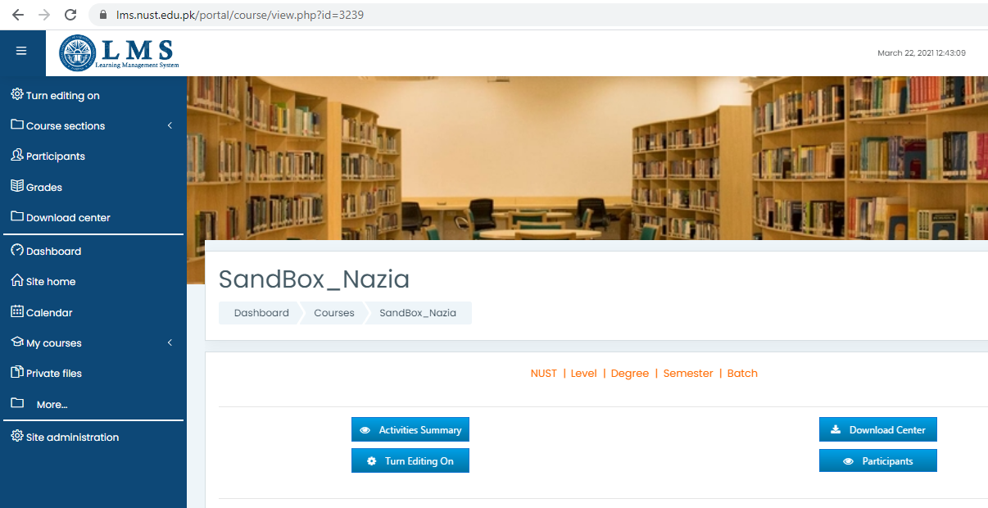

- Click 'Add an activity or resource” and choose 'Turnitin Assignment 2' from the activity chooser.

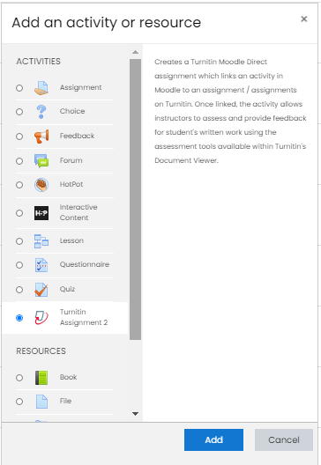

- Write the name of assignment, “Summary section will explain what the students need to submit. You can upload a help or example document from the Additional files area.
- Submission type: The submissions can be made in two different formats i.e. copy and paste and file upload.
- Number of parts: allows for the creation of a multi-part assignment. The students may submit one piece of work in each part.
- Maximum file size: This settings determines the maximum file size for user submissions to each assignment part. The maximum value you can set is dictated by the value set in the course settings, this value is further capped to a maximum file size of 40 Mb which is the maximum allowed file size for the files upload to the Turnitin.
- Allow submission of any file type: This setting allows any file type to be submitted. With this option set to “Yes”, submissions will be checked for originality where possible. With the option “No” the user will not be allowed to upload a file type for which originality report cannot be generated, i.e. image files etc.
- Display originality reports to students: Allows you to display the originality report to the students or restrict its visibility from the students.
- Grades display: This option sets the display mode for grades i.e. percentages or fractions.
- Auto refresh grades / scores: By default, the scores of originality report are automatically refreshed, however you can turn it off and select the manual refreshing of the scores for given assignment.
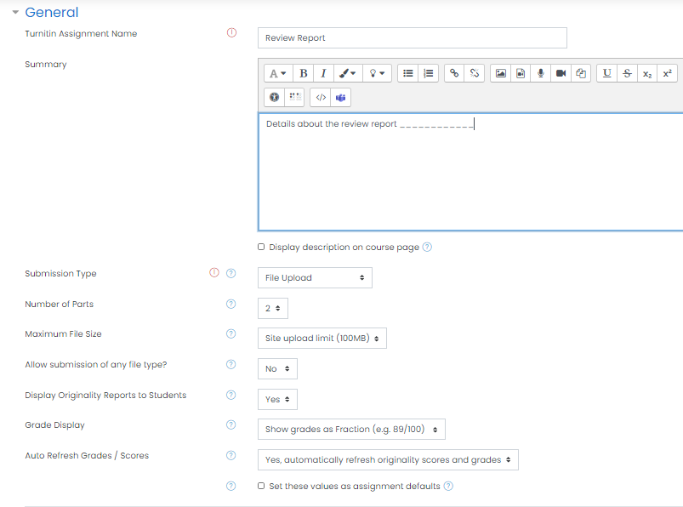
- Grade: Select the type of grades used in this assignment activity. Default maximum grades are 100 points, which can be changed by teacher.
- The name, start date, due date, post date and maximum marks of each part of the assignment can be set using the respective “Assignment part” interface.
  - The Start Date determines the earliest time a student can make a submission to that assignment part.
  - The Due Date determines the date by which time the student must submit their work. If allowing late submissions, the submissions made after this date will be marked in red to show a late submission.
  - The Post Date determines when marks/grades will be released to students.
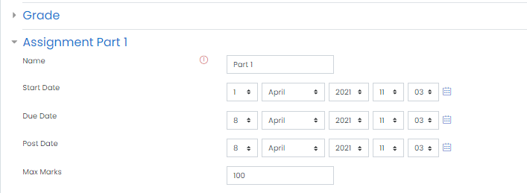
- Allow submissions after due date: This option allows students to submit work after the due date. Late submissions are marked as being late and the actual submission date is recorded.
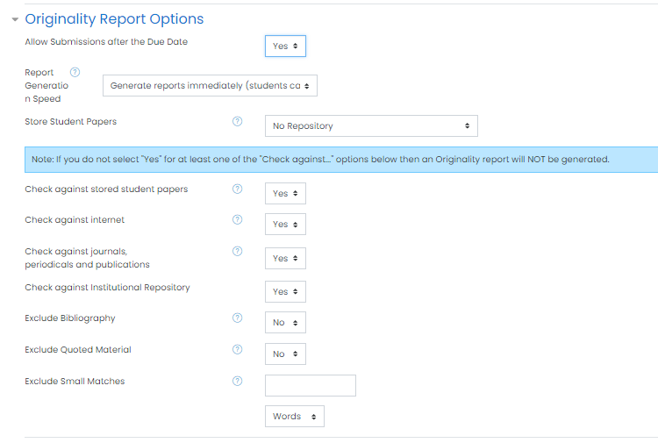
- Report generation speed: There are three options for generating Originality Reports for student submissions:

  - Generate reports immediately, first report is final - Originality Reports for all submissions will be generated immediately. Students cannot resubmit papers. Submissions must be deleted by the instructor to enable resubmission.
  - Generate reports immediately, reports can be overwritten until due date - Originality Reports for the initial submission by each student user to this assignment will be generated immediately. Students may resubmit as often as the student wishes until the assignment due date.
Originality Reports for the second or subsequent submission will require a 24 hour delay before the Originality Report begins processing. Only the latest submission is available to the instructor or student. Previous versions are removed.
Student submissions will compare against one another within the assignment on the due date and time, which may result in a change in the Originality Report similarity index and results at the due date and time. This option is typically used when students are self-reviewing and revising their submissions and able to view the Originality Report. No resubmissions after the due date and time of the assignment.
  - Generate reports on due date - Originality Reports will not be generated for any submission until the due date and time of the assignment. Students may resubmit as many times as needed until the due date and time without receiving reports. Resubmissions may not be made after the due date and time of the assignment.

- Store student papers: This drop down has three options: in the Standard Repository, the institution’s repository, or to not store the papers. The default is to store the student papers in the standard repository.
  - No Repository: The Turnitin is instructed to not store submitted documents in any repository. Only the similarity will be checked.
  - Standard Repository: The turnitin will store a copy of submitted document only in the standard repository.
  - Institutional Repository: This option is not applicable for NUST-LMS.
- Check against stored student papers: If enabled, it checks against the Turnitin student paper repository while processing originality report for papers.
- Check against Internet: If enabled, it checks against the Turnitin internet repository while processing originality report for papers.
- Check against journals, periodicals and publications: If enabled, it checks against the Turnitin repository of journals, periodicals and publications, while processing originality report for papers.
- You can exclude bibliography, quoted material and the small match (if desired) while processing originality report for papers.
- After enabling group settings and restricting the access (if desired), save the assignment.
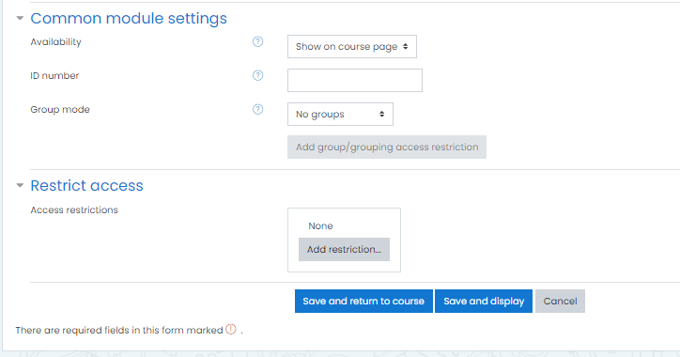

2. Viewing the Turnitin Submission Inbox:
      - When you are logged in as a teacher, you can access the student submission inbox by clicking the 'Submission Inbox' tab.
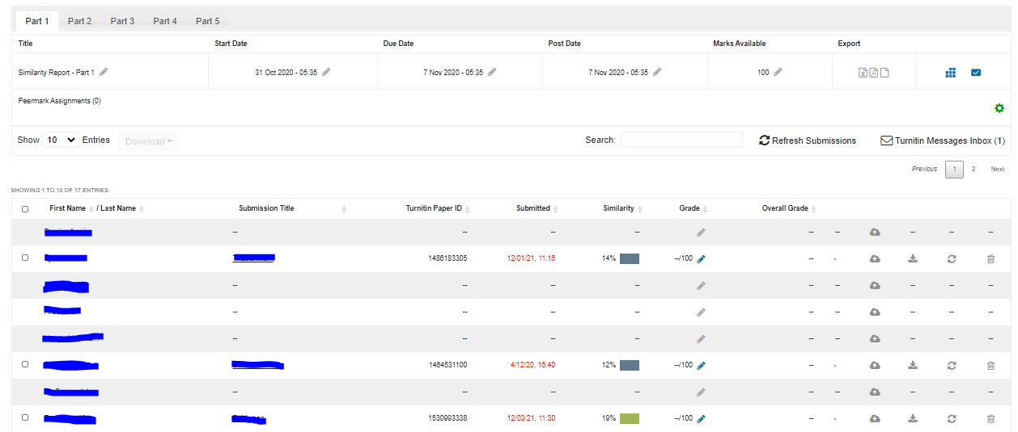
      - For a multi part assignment, each student is listed with a summary of the submissions they have made in respective part of the assignment.
      - The colored bar next to the percentage/ fraction, shows the similarity score of a submission. In order to view/ download the similarity report of a particular student, click on the colored similarity bar.
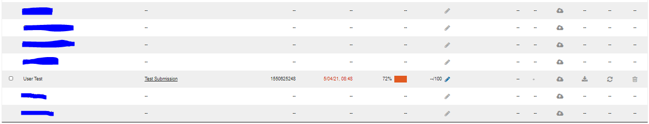
      - Click on the red icon >> percentage to expand the list of the sources, from where the contents of submitted document are matched/ plagiarized.
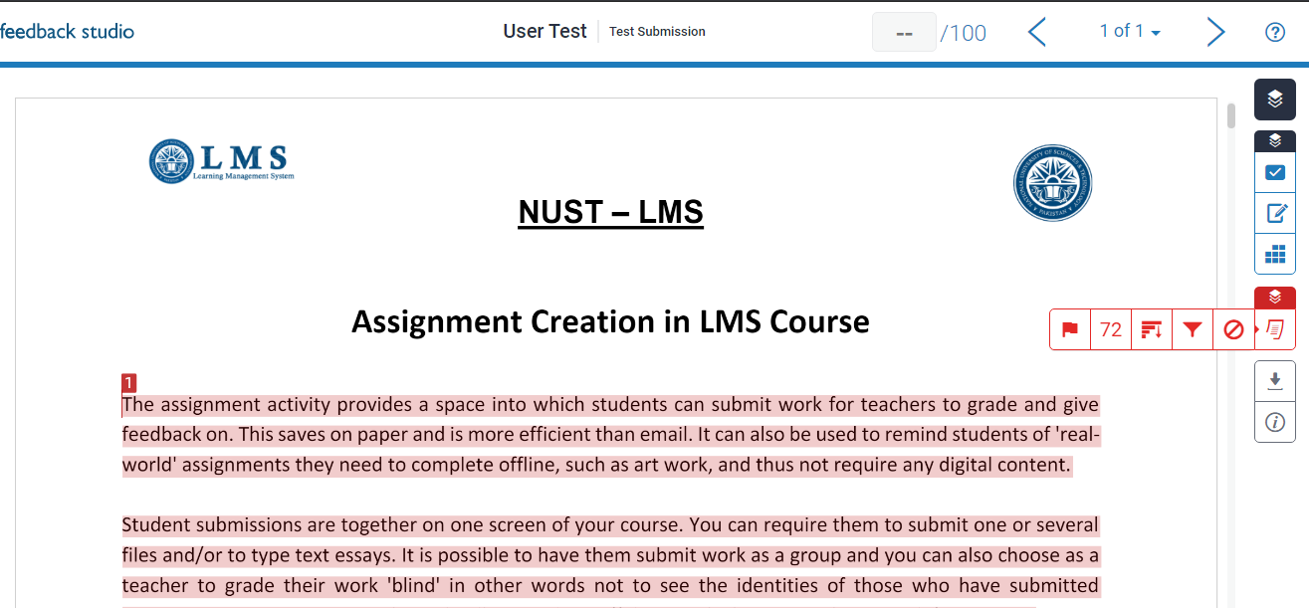
      - Download the similarity report: Click on the download icon and click on the “Current view” to download the detailed similarity report as a PDF document. The summarized digital receipt can be downloaded by clicking the link “Digital Receipt”.
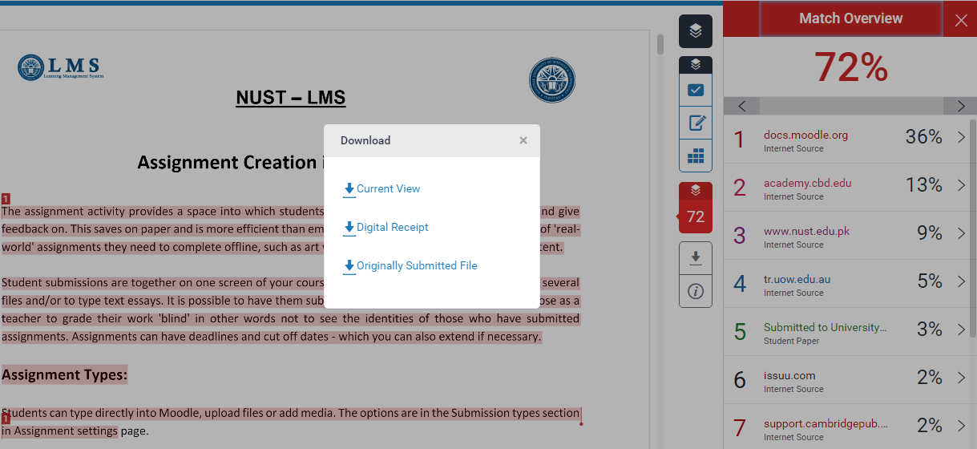

3. Submit Paper on Behalf of a Student
To submit a paper as a teacher on behalf of a student first click on the tab 'Submit Paper' then follow these steps:
            - Search the student's name from the list of students and click on the “Submit paper” icon available in the same row.

            - Enter a submission title.
            - Select the submission part from the drop down list, if only one part is available then this defaults to the single part.
            - For a file upload, click on the Browse... button and select the file you wish to upload.
            - Click on the 'Add Submission' button to submit the file

4. Exclude Sources from the Similarity Report:
With a teacher role, you can exclude the courses from the originality report. However this exclusion is limited to your dashboard. This exclusion will not be applicable if the originality report of the same document is generated through any other turnitin assignment.
- Expand the right arrow, next to the similarity link, which you need to exclude from the originality report.
- Click on the “Exclude Sources” link.
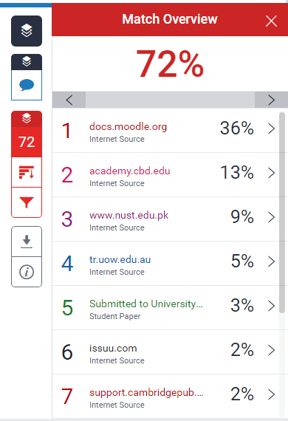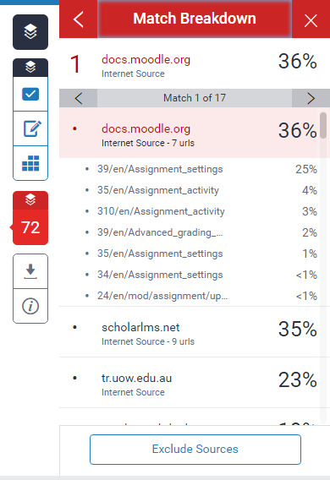
- Check all links you want to exclude.
- Click on “Exclude” button.
- After exclusion of the courses, a decreased similarity index will appear for the same originality report.

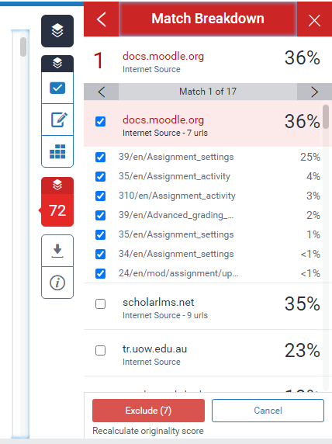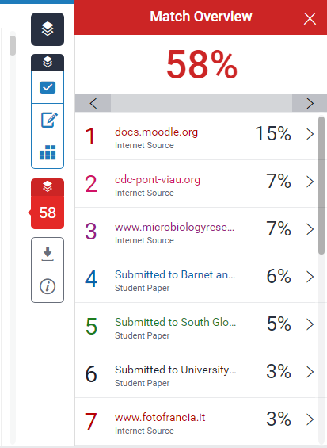
- View all excluded sources: Click on the icon “Excluded sources” to view the list of excluded sources. The sources can be restored using the link “Restore All” or only the selected ones.
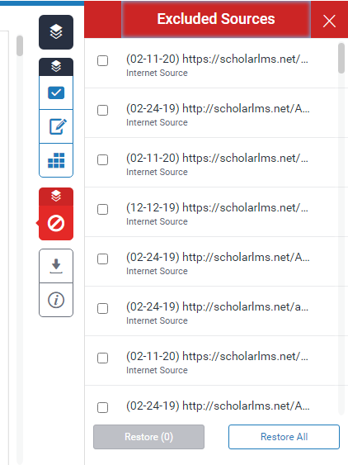
5. Student View for Turnitin Assignment:
- Click on the Turnitin assignment link available in LMS course.
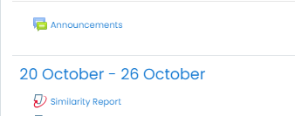
- Choose the assignment part, you need to make submission.
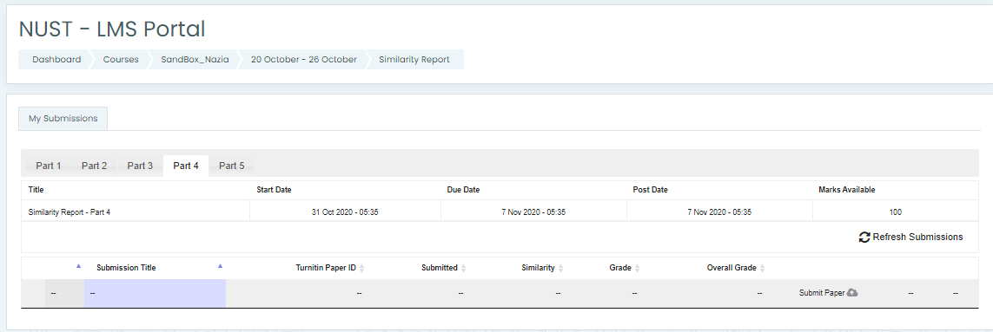
- Write the title for submission and upload the file using file picker or drag and drop and add the submission.

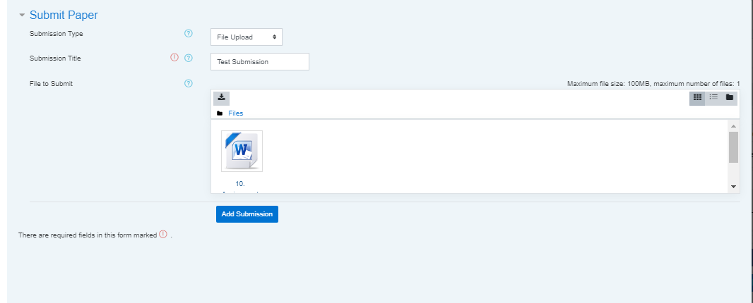
- Click on the close button to return to the assignment main page.
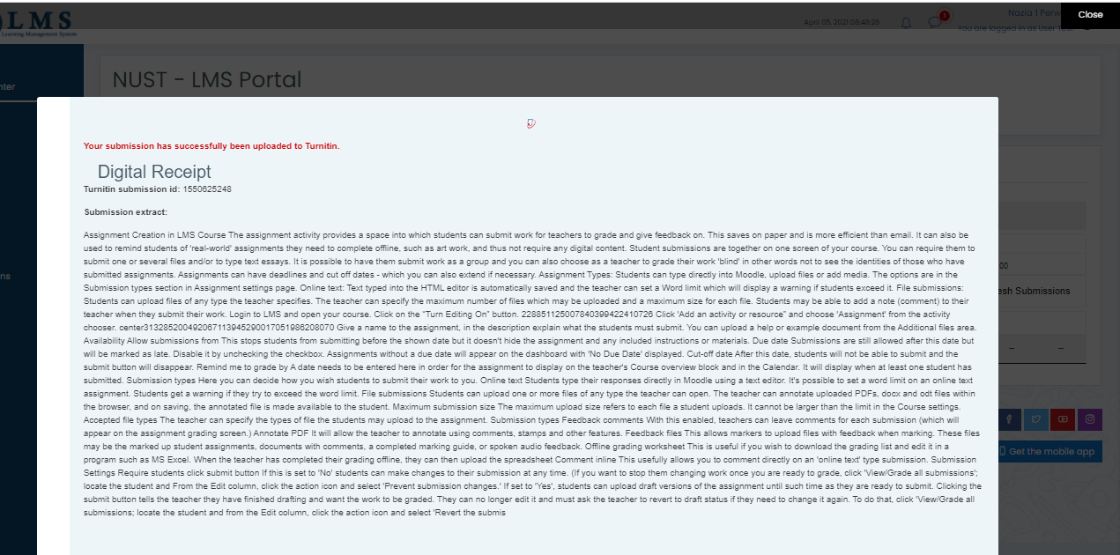
- Right after submission, the pending status will appear for similarity index. After few minutes of submission, click on “Refresh submissions” button.
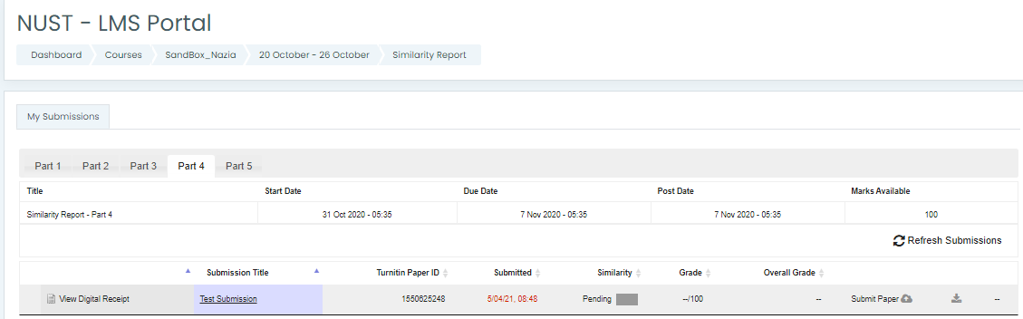
- After processing of the document and generation of the similarity report, the pending status will be updated with actual similarity index in percentage/ fraction along with a colored bar.
- Click on the colored bar to open the similarity report.

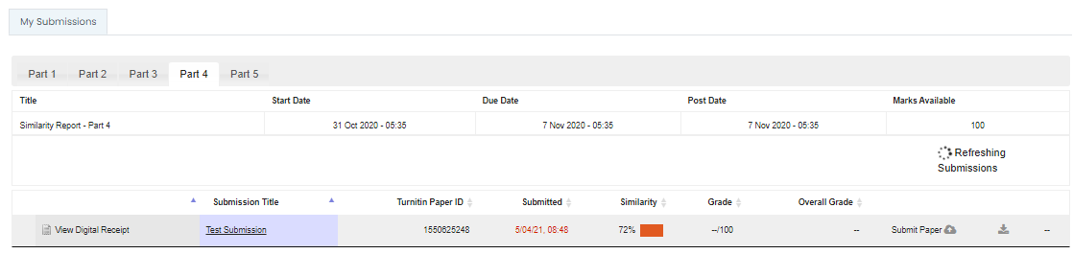
- Click on the percentage (i.e. 72 in the following image) to expand the list of similar documents.
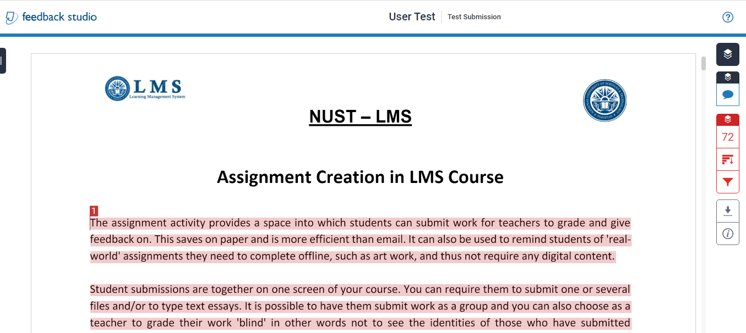
- Click on the download icon to download the similarity report.
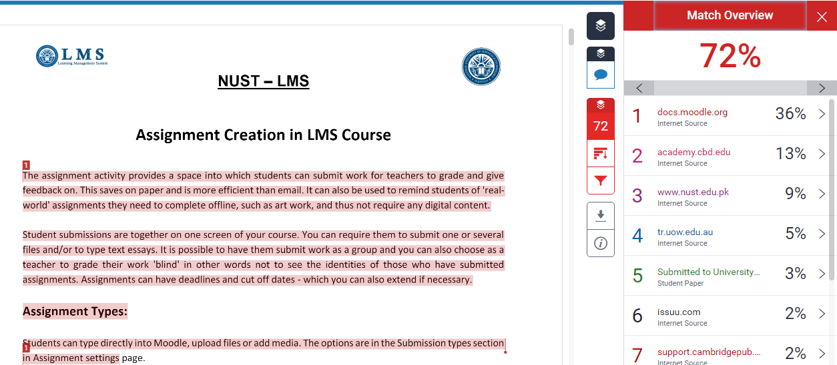

- You can download the detailed similarity report by clicking on the download arrow of “Current view” and the summarized digital receipt by clicking on “Digital receipt”.
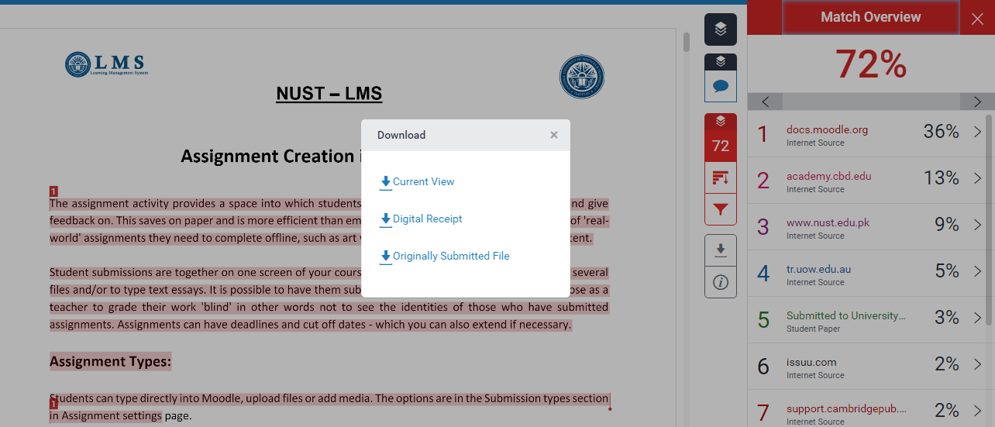
A sample of digital receipt is given below:
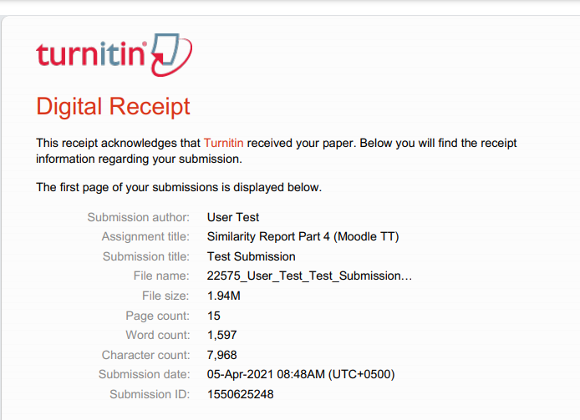
A sample of detailed similarity report, downloaded in PDF format is given below:




